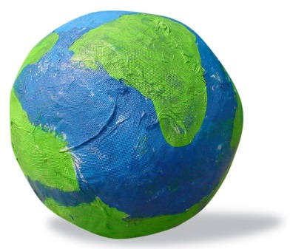

Creation Lesson: Day Five

Needed Supplies:

Paper plates

Crayons and or markers

Glue on eyes (optional, could just draw them as well)

Bible
Bible Lesson
Review
“What did God create on the first day of creation?” heavens, earth, light
“What did God create on the second day of creation?” the sky to separate the water
“What did God create on the third day of creation?“ land, plants with seeds, plants with fruit with seeds
“What did God create on the fourth day of creation?” sun, moon and stars
Today we will see what happens next…
Read Genesis 1:20-23 aloud to the children.
“God said, “Let the waters be filled with living things. Let birds fly above the earth across the huge space of the sky.” So God created the great creatures of the ocean. He created every living and moving thing that fills the waters. He created all kinds of them. He created every kind of bird that flies. And God saw that it was good. God blessed them. He said, “Have little ones and increase your numbers. Fill the water in the oceans. Let there be more and more birds on the earth.” There was evening, and there was morning. It was day five.”
NIrV (New International Reader’s Version)
Read the verses (story) again, but this time have the children make fish faces and flap like a bird when you come to those parts.
Discuss the Bible Reading
When you are finished reading the story the second time, ask the children the following questions so that you can know they understood it.
“Who was in the story?” God
“What did God create in the story today?” all the things in the water and the birds in the sky
“Did God think that it was good?” Yes
“What number day was it in the story today?” Five

Activity: Birds and Fish
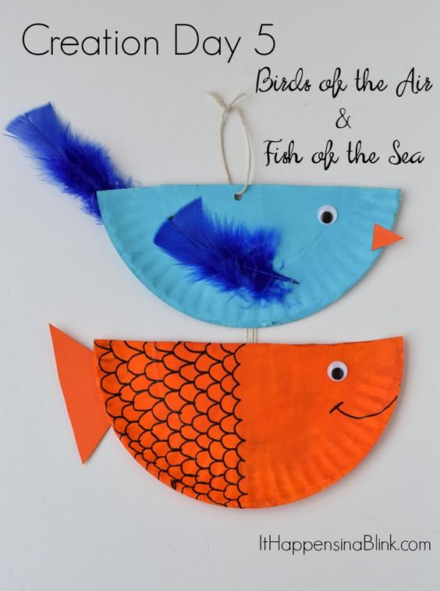
Use Paper plates, crayons or markers and other materials to have children choose to make a fish or a bird.
Activity: Bible Verse Memorization
“He created every living and moving thing that fills the waters. He created every kind of bird that flies.” Genesis 1:21 (New International Reader’s Version)
Have the children do the following hand motions along with repeating the words after you, to help them learn the Bible Verse:
“He”—hold hand up with fingers towards the sky…the hand is raised to the heavens and then downward in a sign of respect
“created”—the fists twist on top of one another, as if they were putting something together
“every living and moving thing”—move the hand mimics the movement of a fish tail
“that fills the waters”—hold three fingers up and tap the chin
“He”— hold hand up with fingers towards the sky…the hand is raised to the heavens and then downward in a sign of respect
“created”— the fists twist on top of one another, as if they were putting something together
“every kind of bird”—the thumb and forefinger mimic the action of a bird’s beak
“that flies”—move arms like the flapping wings of a bird
“Genesis 1”—hold 1 finger up
“21”—hold index finger out and push thumb into it
Do this a few times with the children. Make it fun for them to do the motions and say the words. Involving them in active learning is essential for memorization at this age.
Review:
Go over the hand motions with the children to help them remember what was created on each day. After you go over them, ask them what was created on each day and have them do the hand motions.
“First there was darkness and light” (cover eyes with hands and then release)
“Then there was water and sky” (make waves with hands & arms & then wave up in the air)
“Then there were dirt and trees” (wiggle fingers in front of you for dirt & grow up like a tree)
“Then there were was the sun and the moon” (put arms above head and then like you are sleeping)
“Then God made fish & the birds” (put hands together and wiggle like a fish then flap arms like a bird)

